**SQL Project on Online Book Stores**

**Create Tables:**

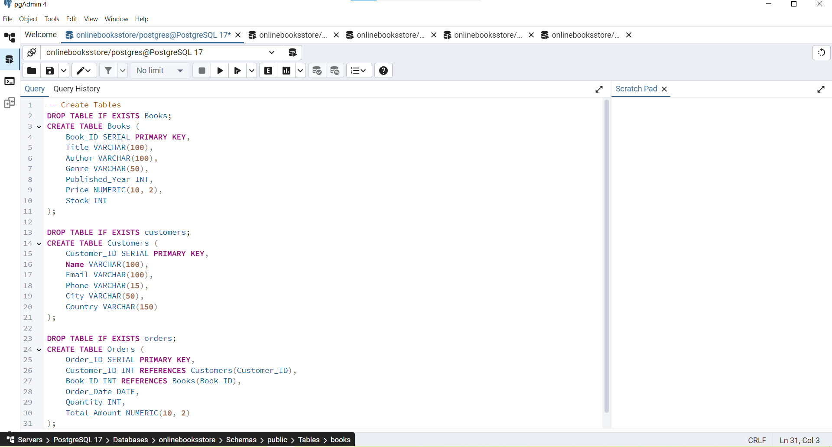

**Basic Queries:**

1. Retrieve all books in the "Fiction" genre

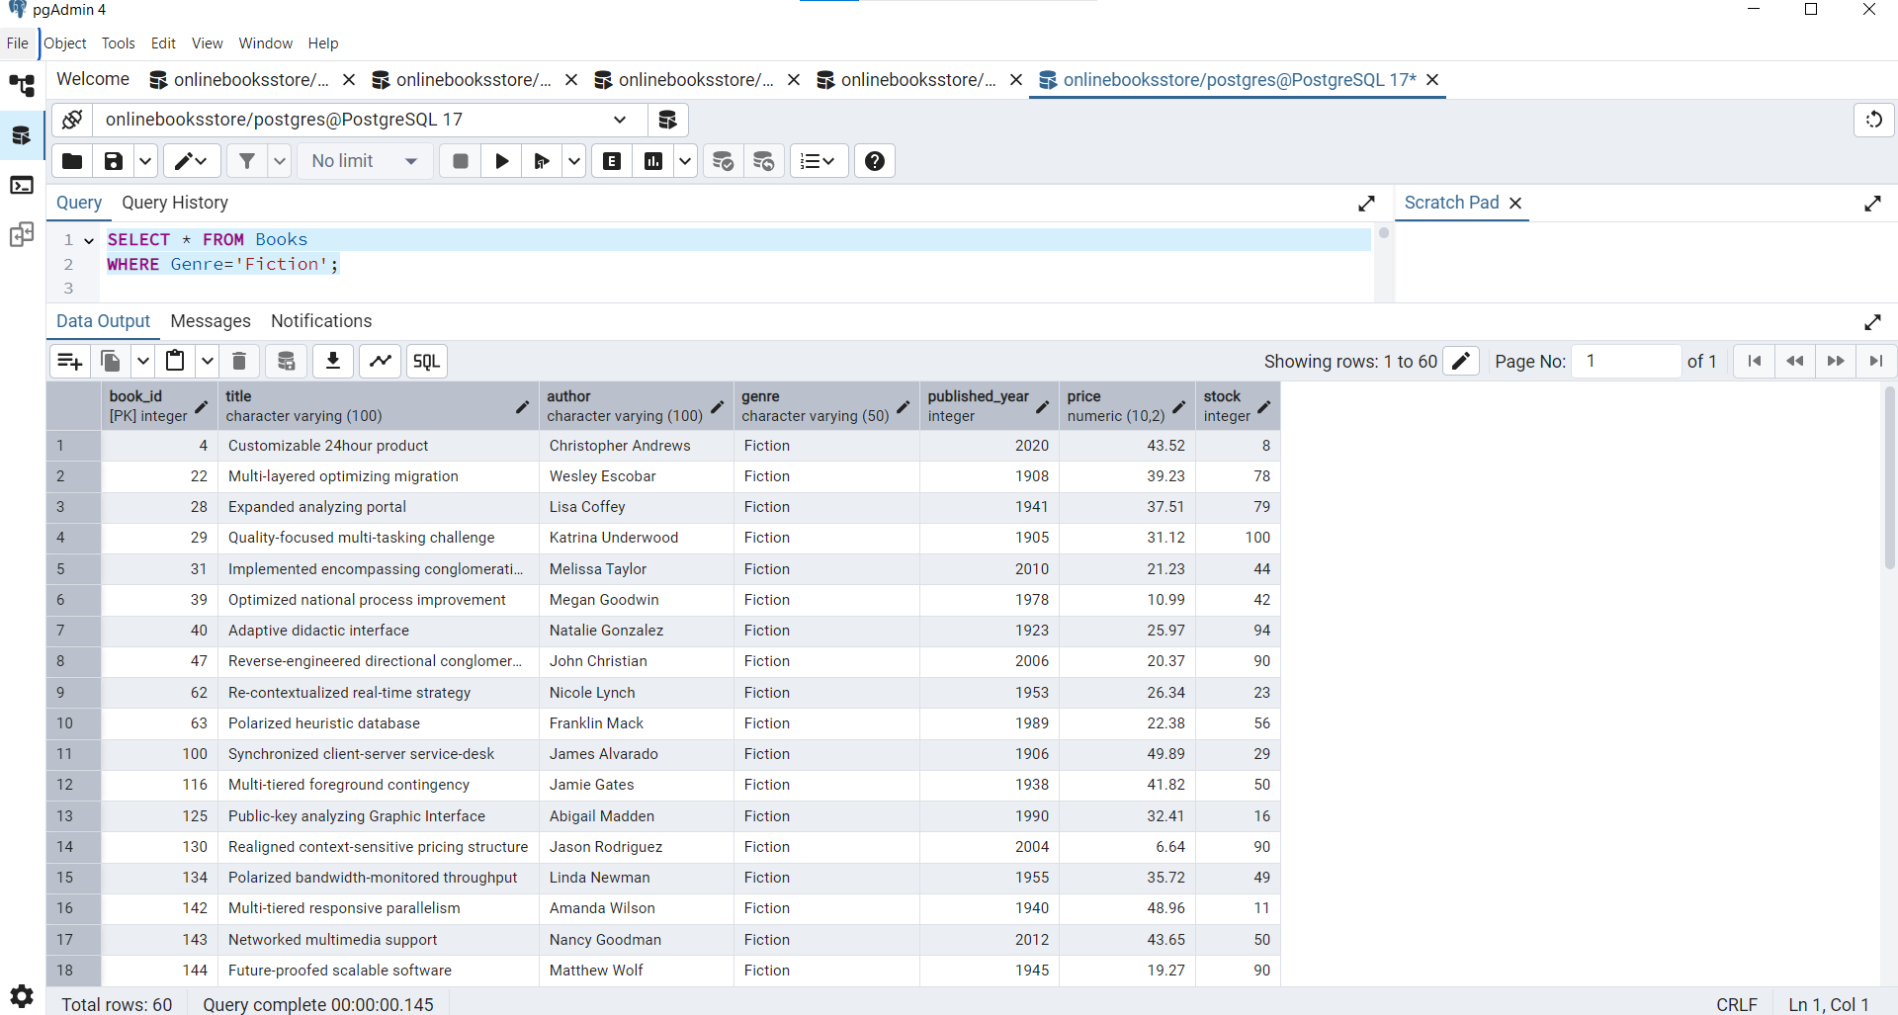

1. Find books published after the year 1950:

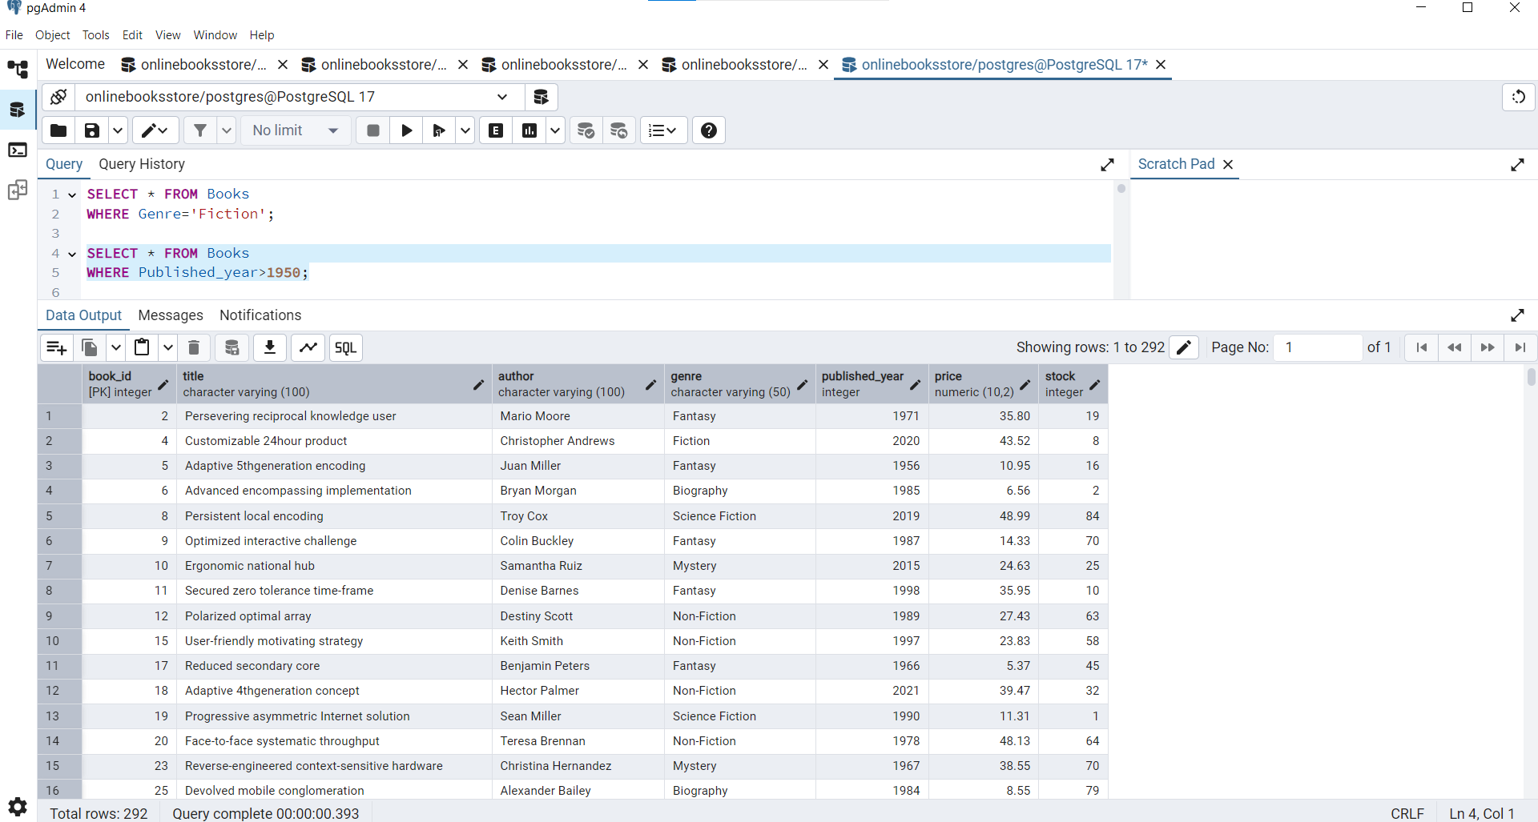

1. List all customers from the Canada:

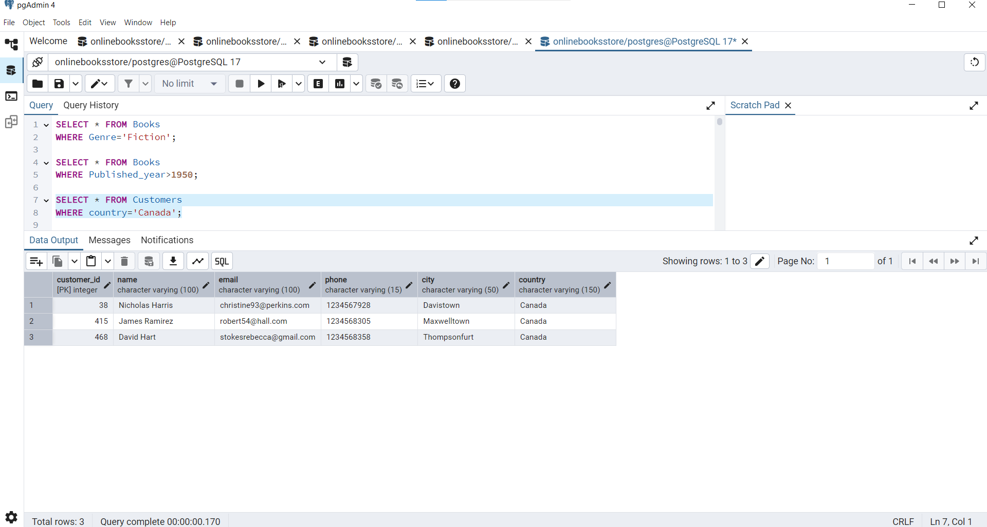

1. Show orders placed in November 2023:

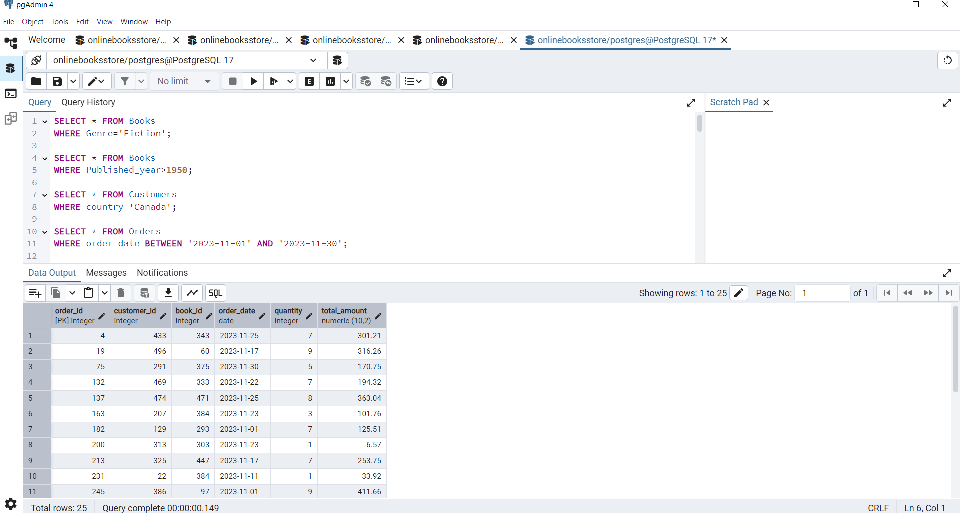

1. Retrieve the total stock of books available:

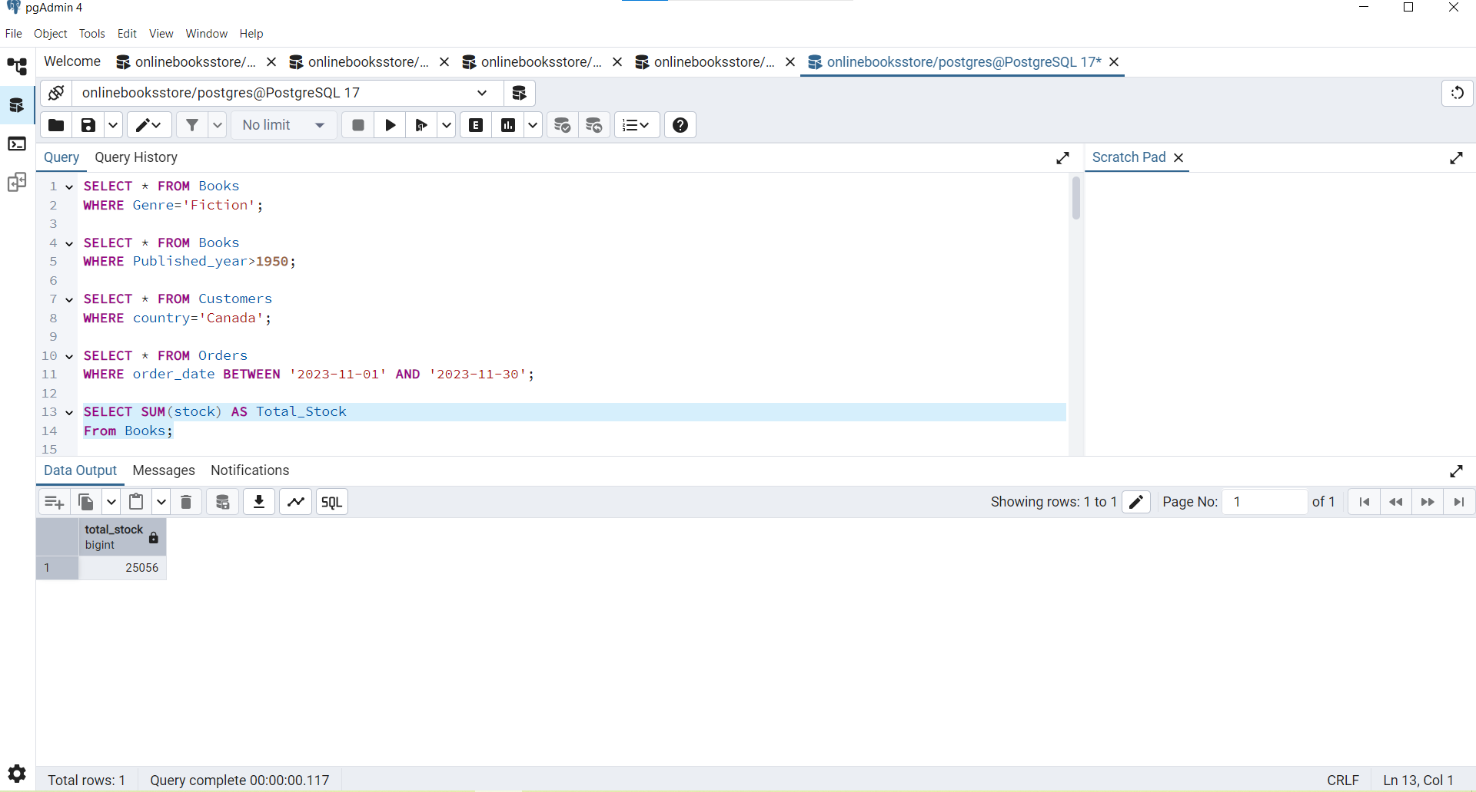

1. Find the details of the most expensive book:

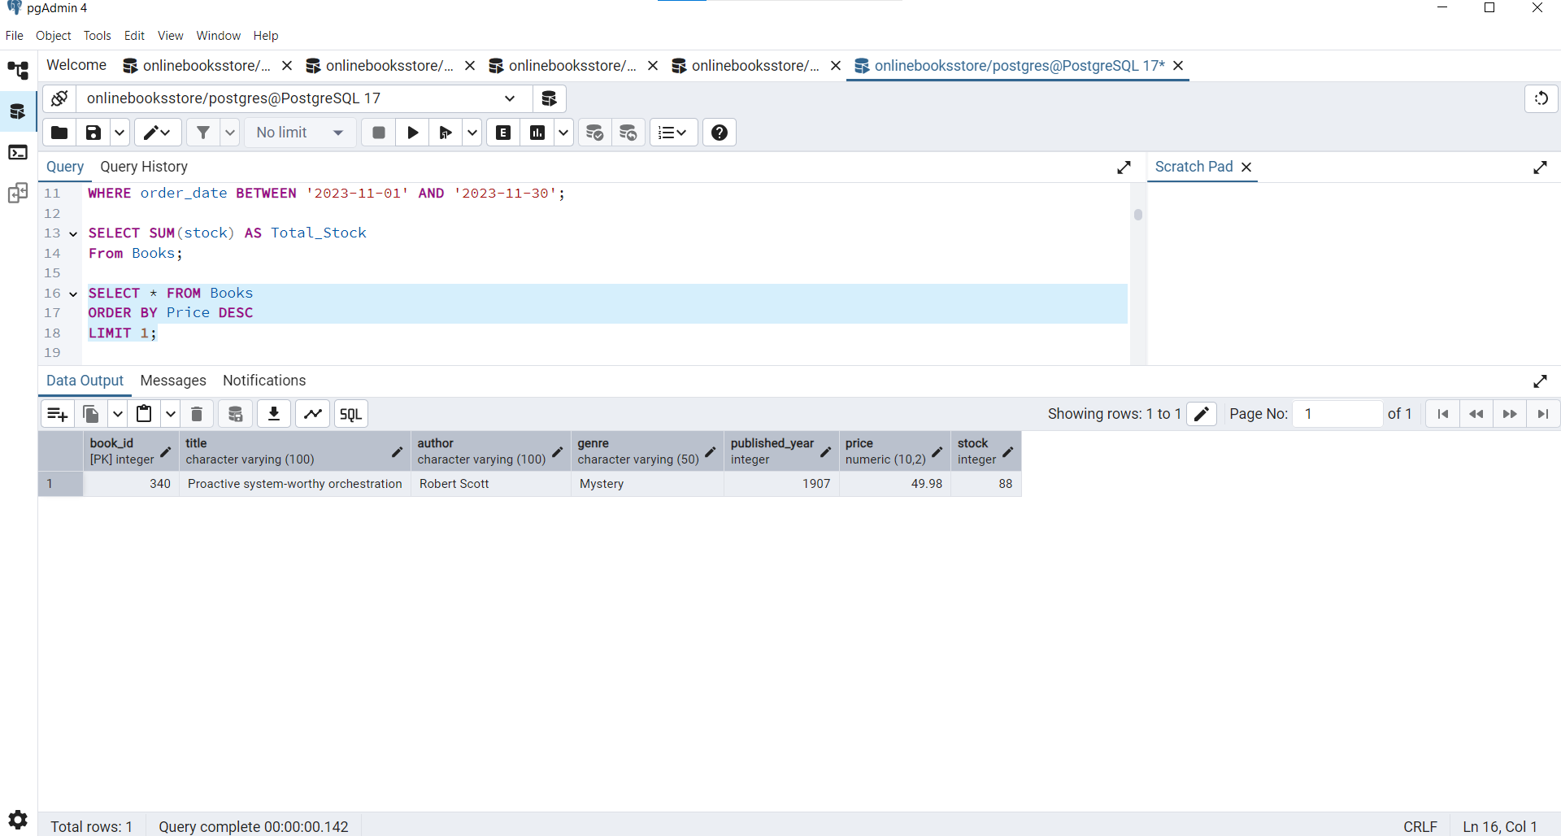

1. Show all customers who ordered more than 1 quantity of a book:

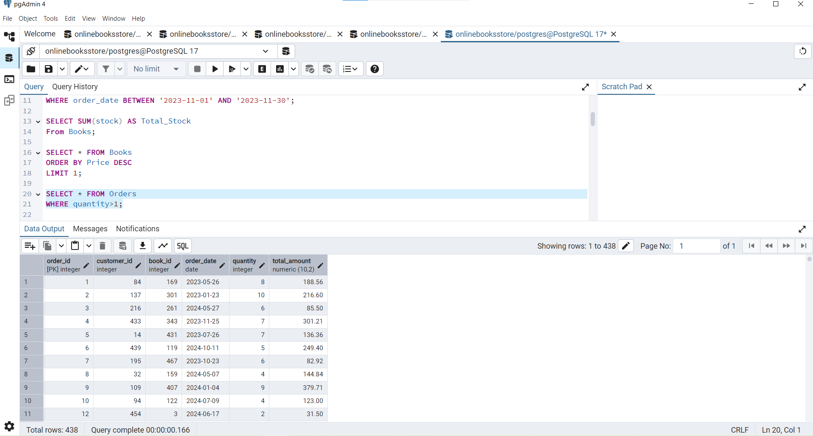

1. Retrieve all orders where the total amount exceeds $20:

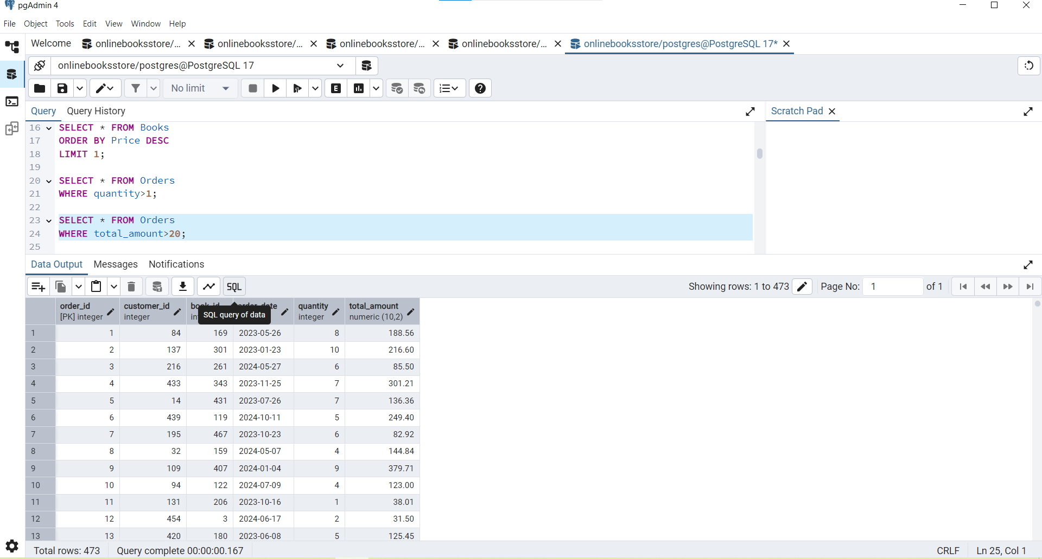

1. List all genres available in the Books table:

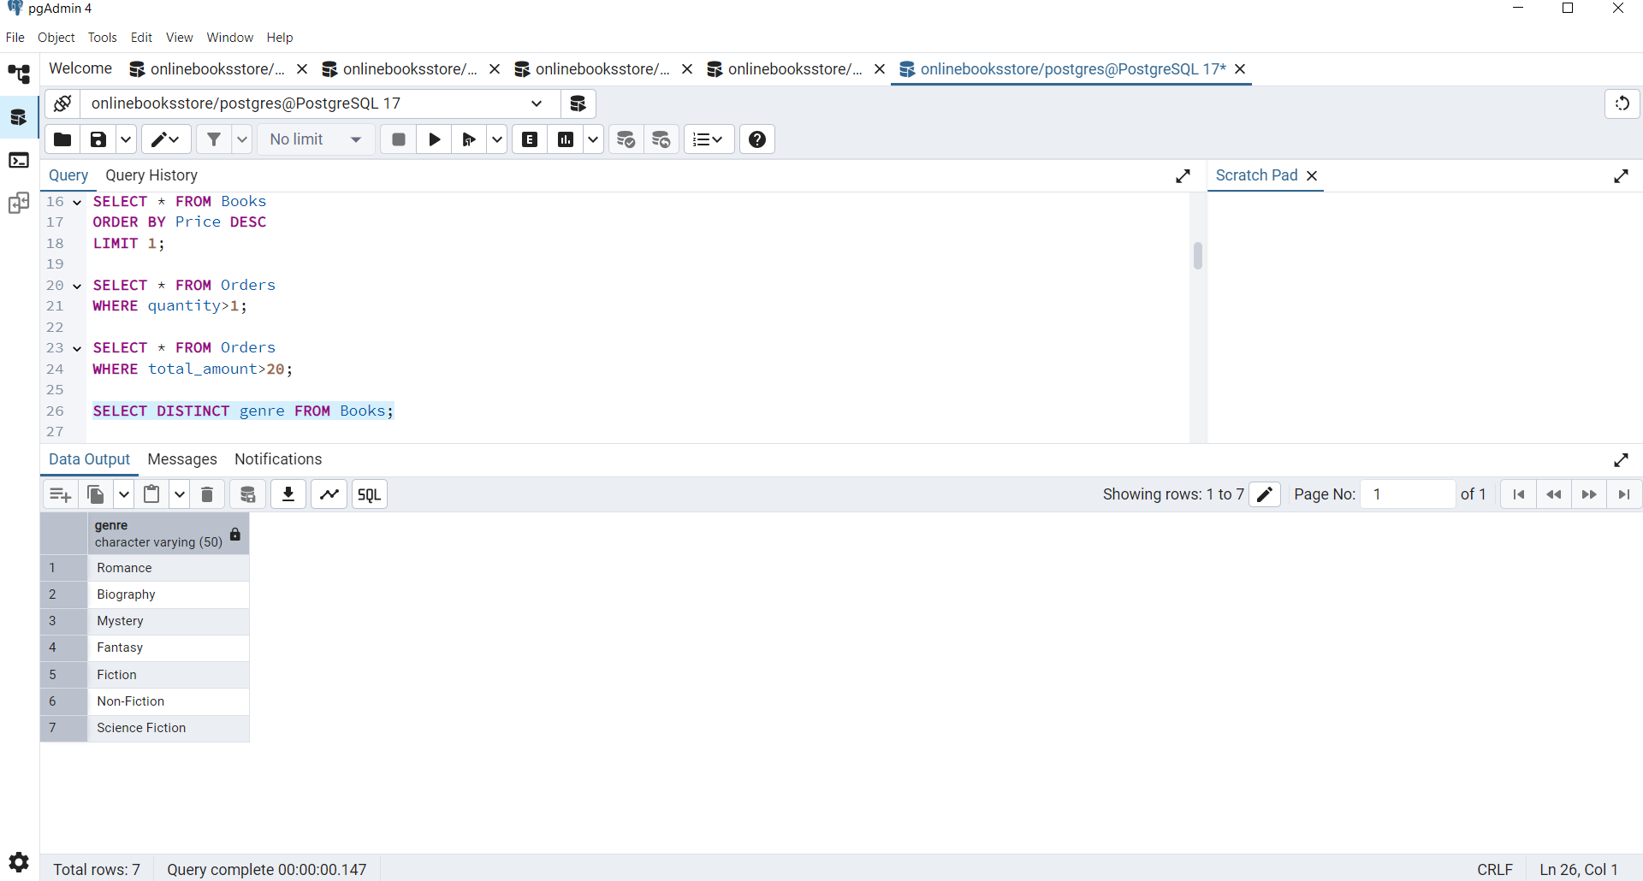

1. Find the book with the lowest stock:

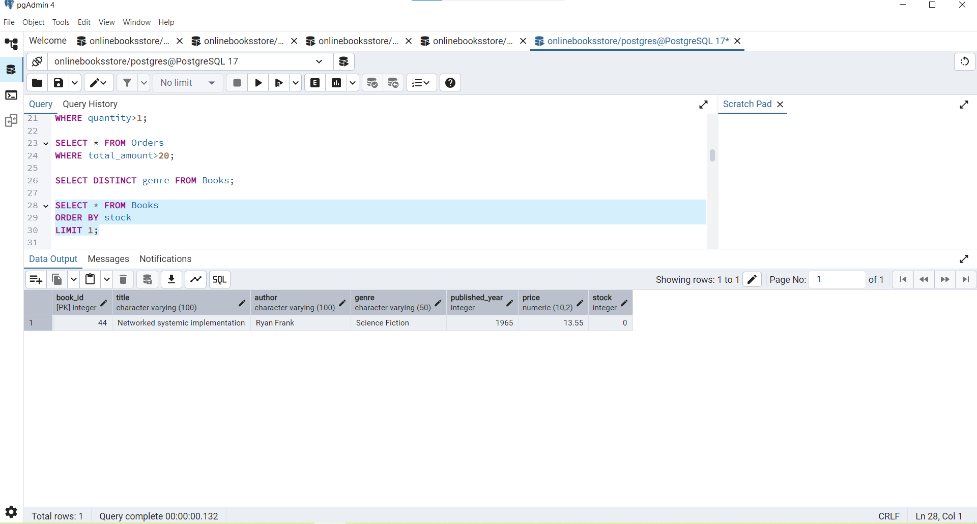

1. Calculate the total revenue generated from all orders:

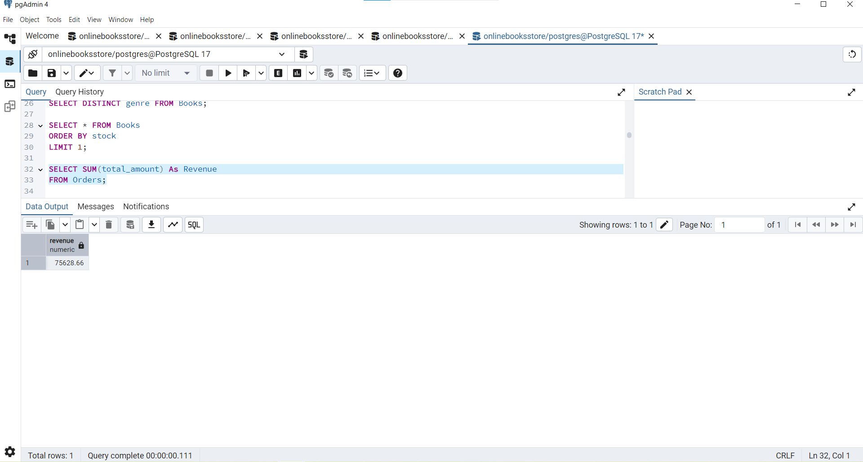

**Advance Queries:**

1. Retrieve the total number of books sold for each genre:

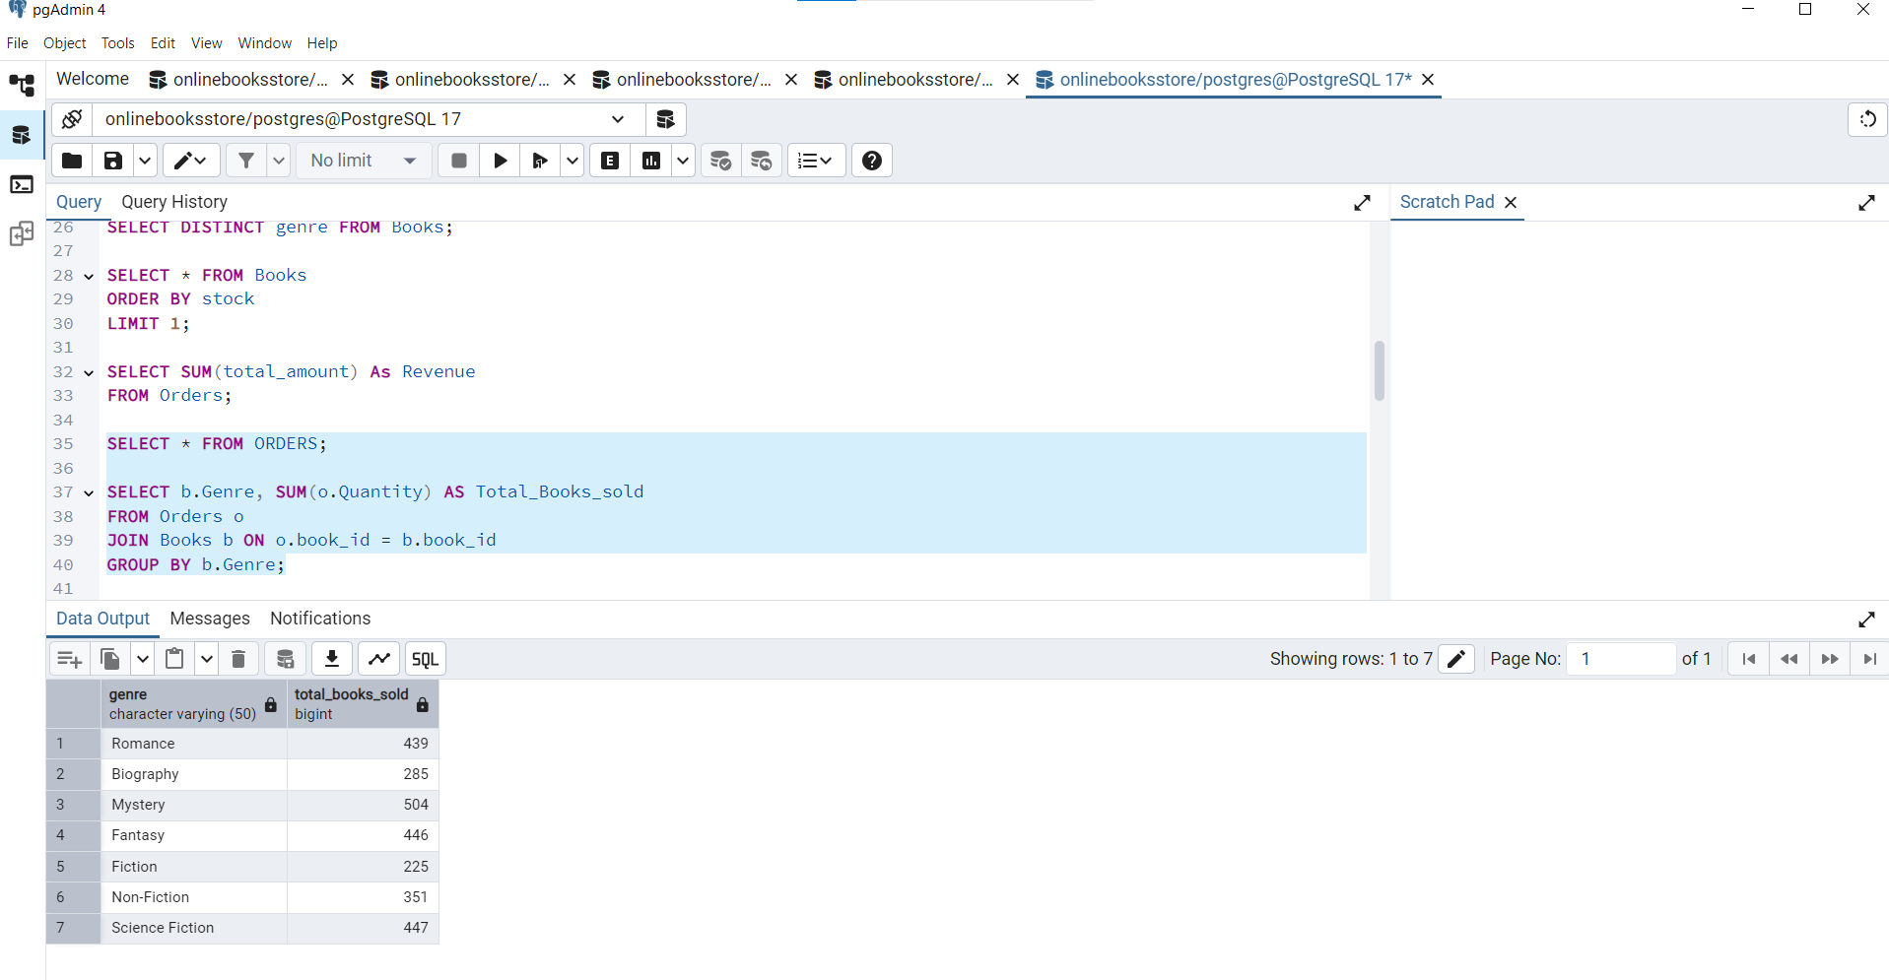

1. Find the average price of books in the "Fantasy" genre:

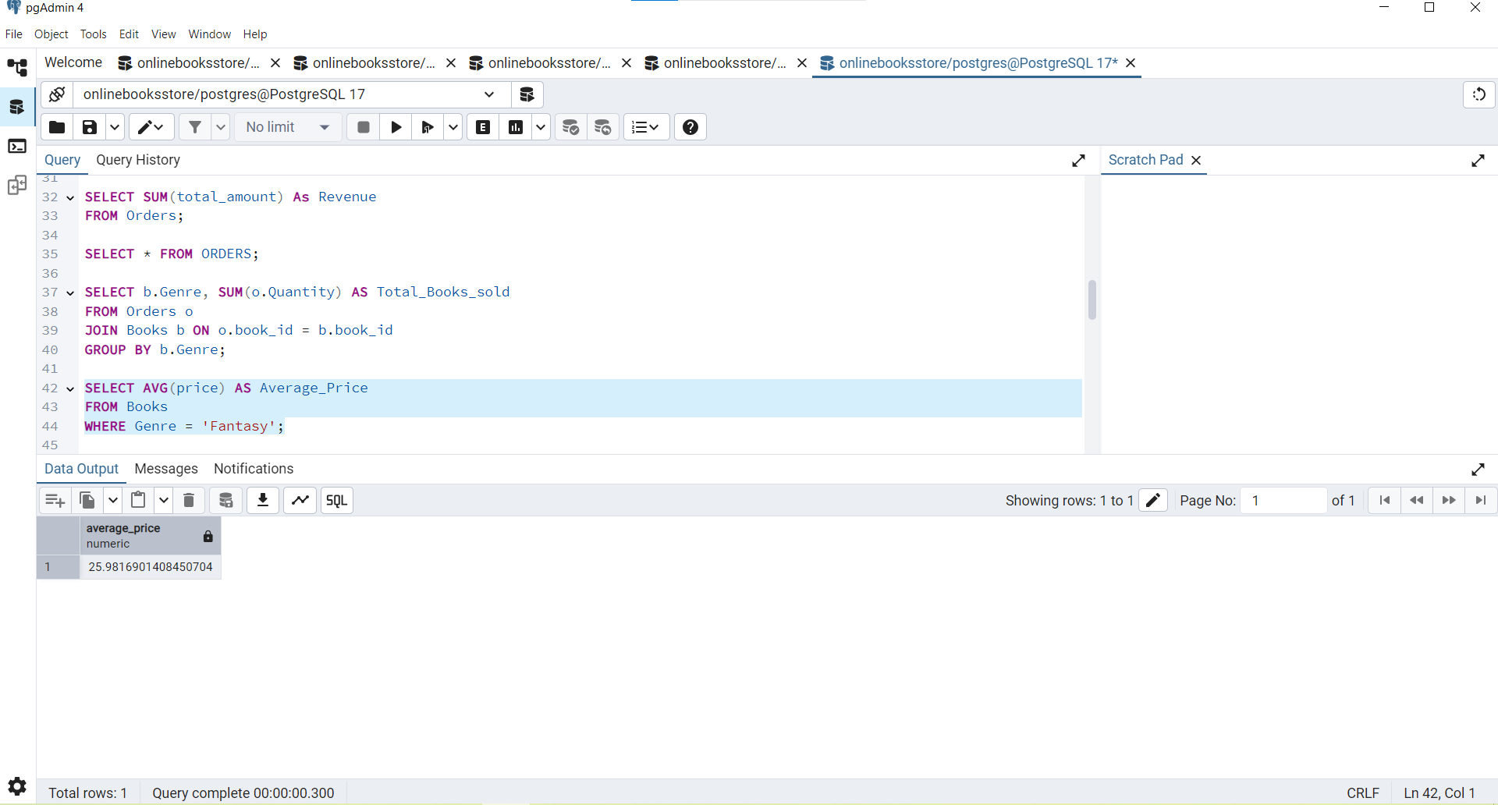

1. List customers who have placed at least 2 orders:

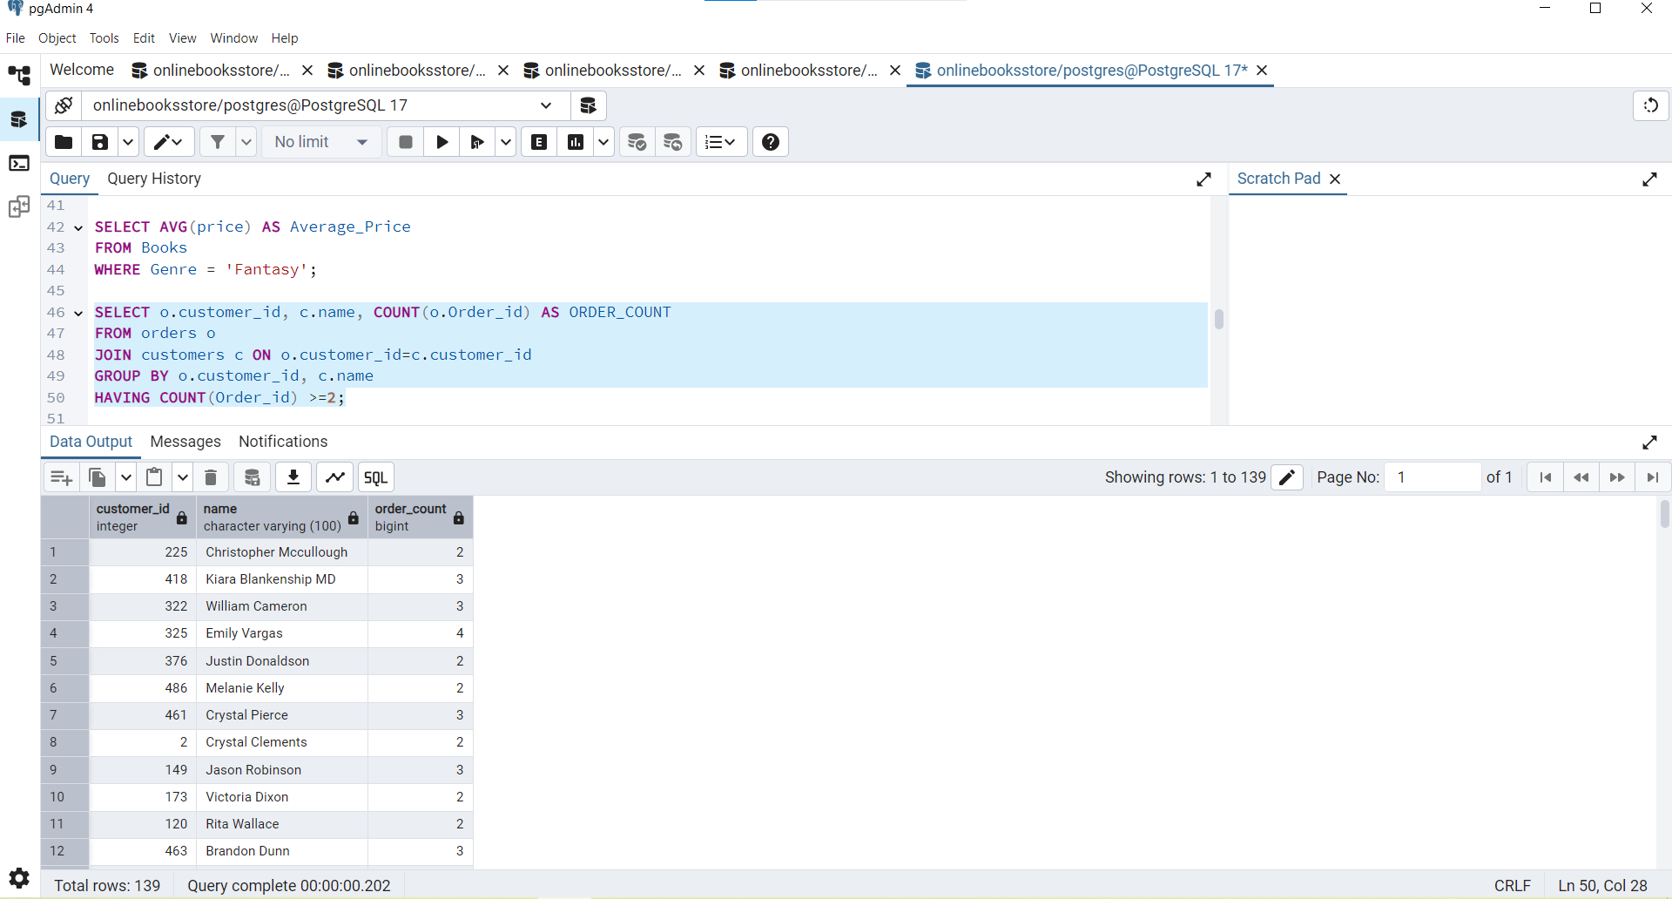

1. Find the most frequently ordered book:

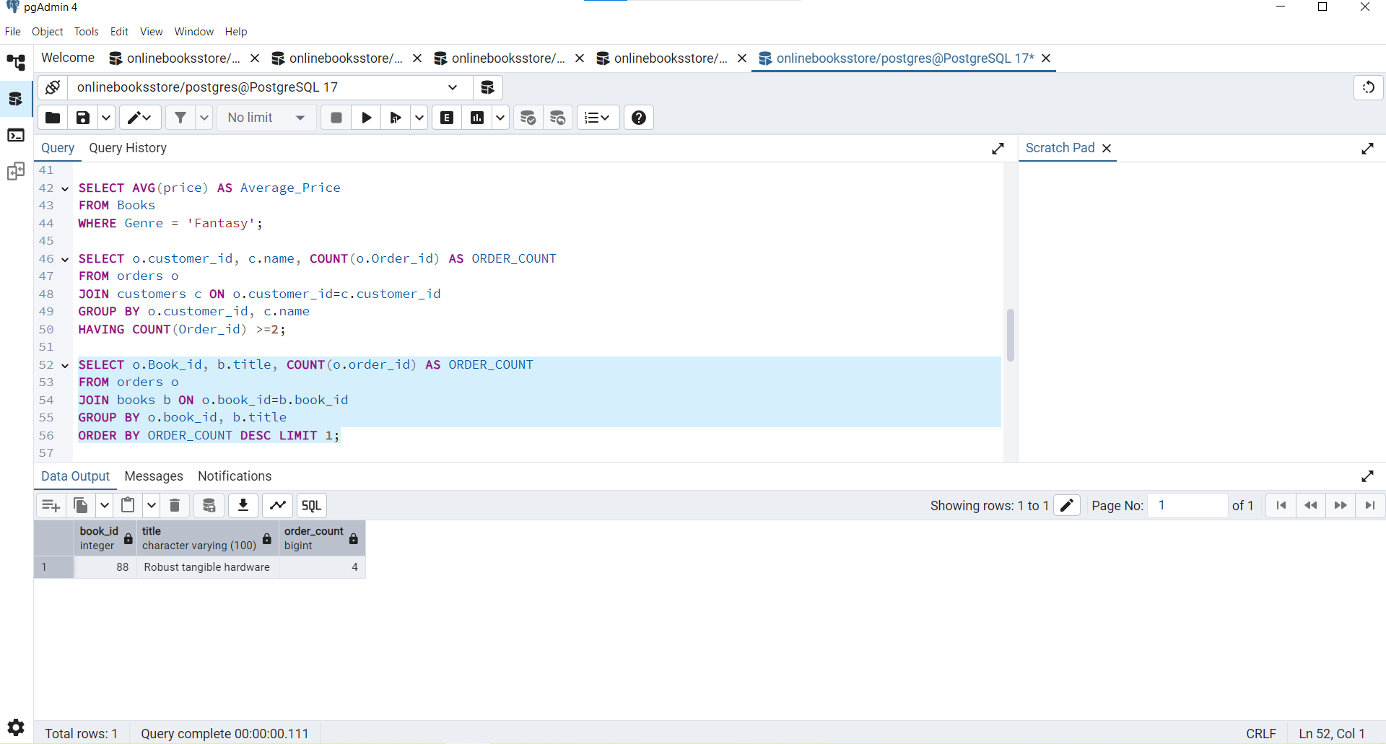

1. Show the top 3 most expensive books of 'Fantasy' Genre :

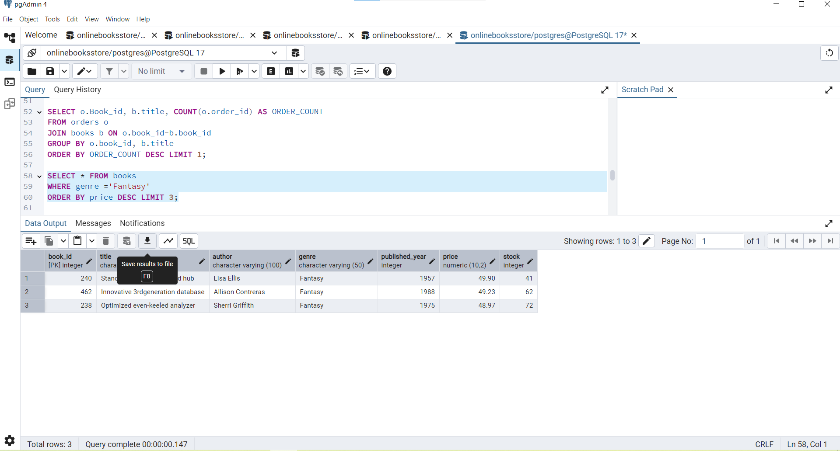

1. Retrieve the total quantity of books sold by each author:

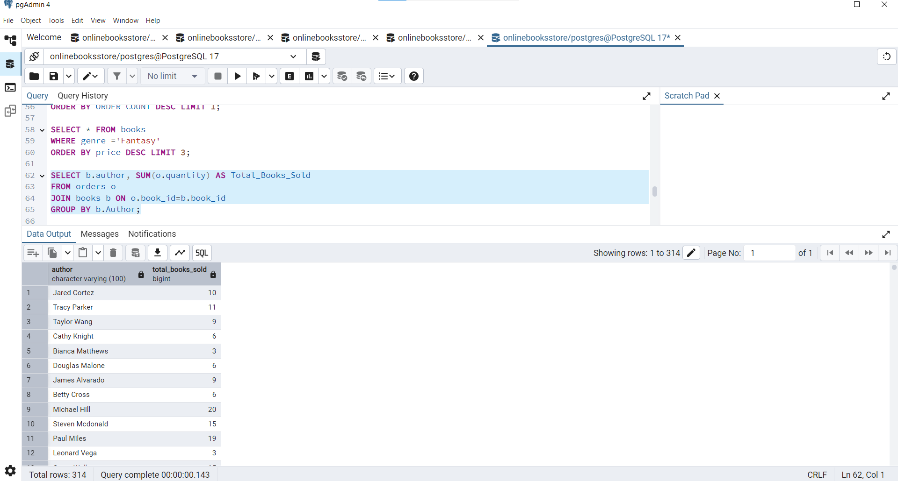

1. List the cities where customers who spent over $30 are located:

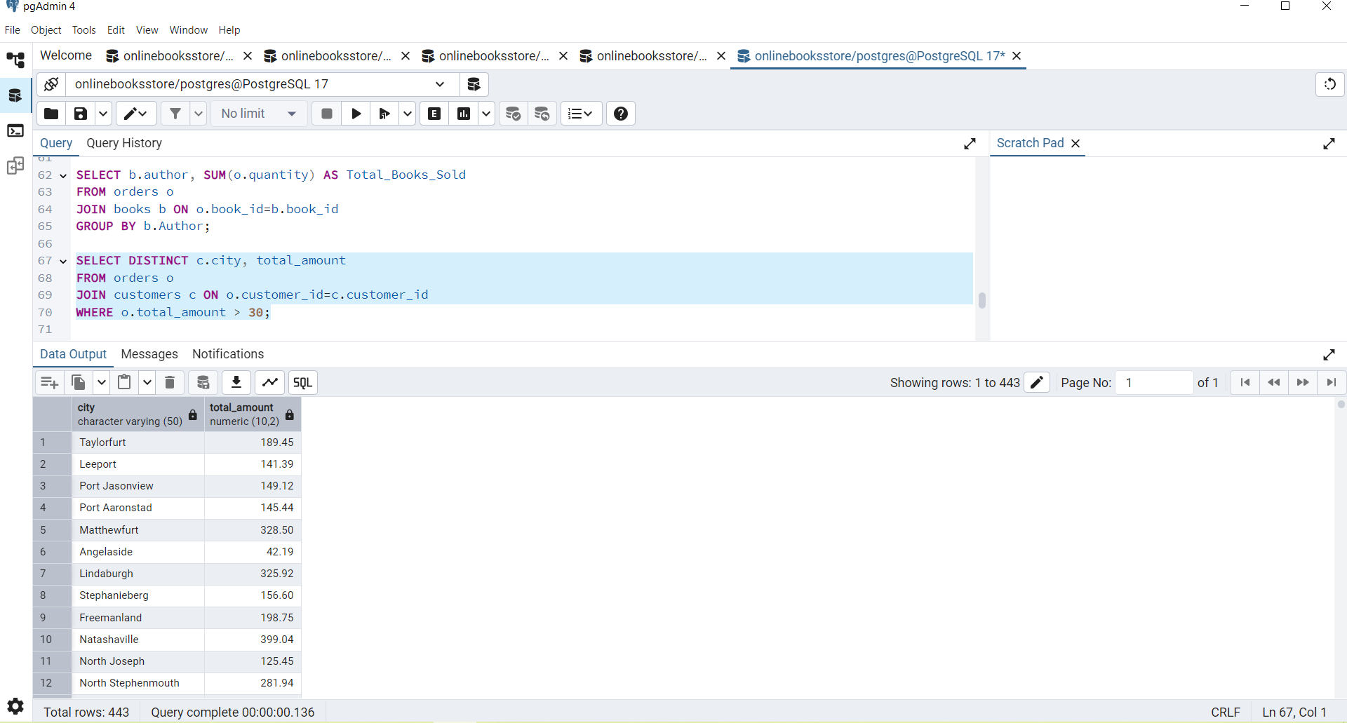

1. Find the customer who spent the most on orders:

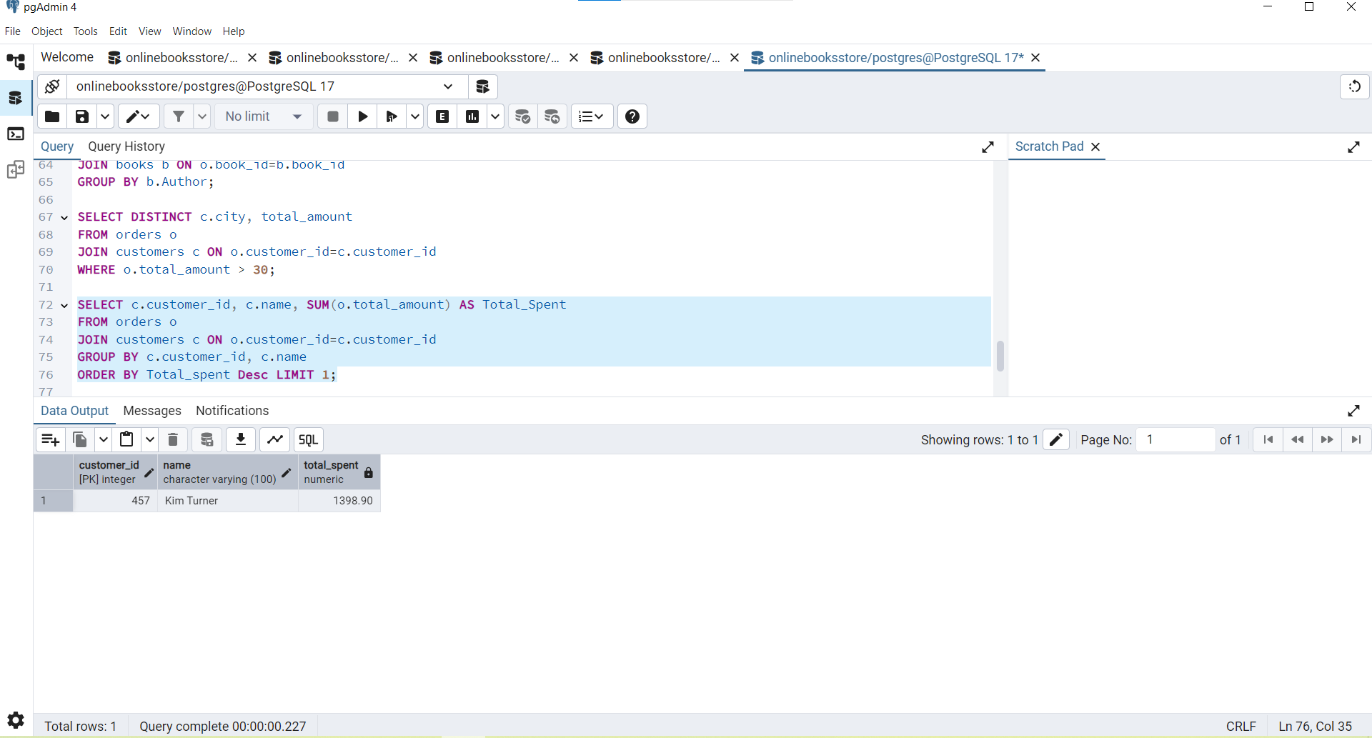

1. Calculate the stock remaining after fulfilling all orders:

